WEEK 3
Date: |  | Day: MONDAY |  |  | Strand: All Around Us
 |  |  |  |  | Sub Strand: Water
Class: KG 2 |  |  | Class Size:
Content Standard:  K2.6.3.1 Demonstrate understanding that water is an important natural resource that helps all living things, human, plants and animals |  |  |  | Indicator:  K2.6.3.1.7 measure, estimate and compare the capacity of different containers of water
Performance Indicator:  - Learners can draw and color different sources of water.  - Learners can measure, estimate and compare the capacity of different containers of water |  |  |  |  | Core Competencies:  Communication and collaboration, Critical thinking, Personal Development and Leadership
Keywords: holds more, holds less, compare, heavy, light, heavier, lighter.
Reference : KG Curriculum P.g. 166-169
Phase/Duration | Learners Activities |  |  |  |  | Resources
PHASE 1: STARTER | Let learners sing a song in relation to the lesson.  1. Did you enjoy the song?  2. What words did you hear in the song?
PHASE 2: NEW LEARNING  CIRCLE TIME | Put learners in a community circle.  Let them discuss where they get water from in their community. e.g. streams, pipe, lagoon, etc
GROUP ACTIVITY 1  (OUTDOOR) | Demonstrate to learners by filling two different containers.  E.g. 1 litre bottle, and 500mls bottle with water.  Fill the smaller bottle up to the brim and pour it into the 1 litre bottle. Have learners tell you what they observed.  There is still space in the bigger one which means the bigger bottle holds more water than the smaller one.  The smaller container holds less water than the bigger bottle.  Put learners into groups of four. Give them two different plastic cups.  Let them fill one and pour it into the other one and compare which cup holds more or less water.  Note: This activity should be done outside the classroom  Give different containers to learners. They select any two containers on their own, fill one with water and pour it into another one.  They use the expressions learnt to describe what they saw  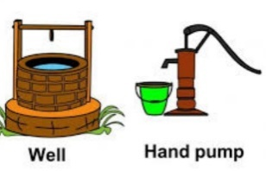  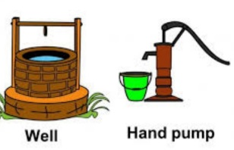  Have learners look at the conversational poster again and draw and color any two sources of water.  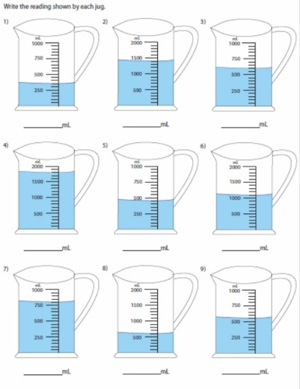  Provide different containers of water in the classroom and have learners fill the bottles, bowls and the containers, measure and estimate the volumes and compare the weight.  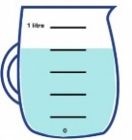  Have learners use the different liters of existing water bottles and check which weight is heavier or less heavy.  Activity time: Measure water with different sizes of bottles and compare volumes of different sizes of containers of water.  Set up stations for different uses of water  Assessment  Have learners work in pairs. Give them milo tins and milk tins. Ask them to fill the milo tin with water up to the brim and pour it into the milk tin and compare. They should use the expression “holds more than / holds less than” |  |  |  |  | bowls of different capacities, plastic bottles and milk tins
PHONICS | Engage learners to sing songs and recite some familiar rhymes that relates to the target sound.  Guide learners to pronounce and write the target sound in the sand tray or exercise books.  Have learners say three or four words that contain the target sound.  Using flash cards, learners read words that contain the target sound.  1. What sound have we learnt today?  2. Which other letter sound do you know?  3. Mention any object in the classroom or home that begins with the target letter sound. |  |  |  |  | Word cards, letter cards.
GROUP ACTIVITY 2  (INDOOR) | Have learners recite the rhyme “can you count 1,2,3” or any other related rhyme  Call two learners to the front of the class. Make sure one is taller than the other. Let them compare their height by putting their backs together. The class calls out the name of the person who is shorter/taller e.g. Dede is shorter than Edem and Edem is taller than Dede.  Put learners into groups of four. Give them sticks of different length, straws, pencils.  Have them take two sticks and compare the length. Make sure they put the two on the same base.  Have them compare two different objects e.g. plastic bottles of different heights.  Let them move round the classroom and compare any two objects that they see. E.g. pencils, markers etc. make sure they use the expression shorter/longer than.  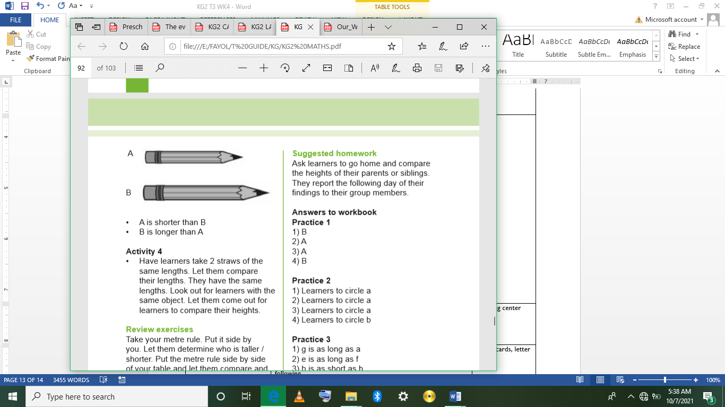  Have learners take 2 straws of the same lengths. Let them compare their lengths. They have the same lengths. Look out for learners with the same object. Let them come out for learners to compare their heights  Assessment  Take your metre rule.  Put it side by you. Let them determine who is taller / shorter. Put the metre rule side by side of your table and let them compare and determine which is taller/shorter |  |  |  |  | leaves, stones, bottle caps, books, etc
LEARNING CENTER | Engage learners to play freely at the learning centers.  Observe, join in and ask learners questions frequently to guide their play and to support their understanding in what they are learning. |  |  |  |  | Learning center
STORY SHARING | Tell learners a story.  Pause regularly and ask questions to make sure learners are following.  Engage learners to act parts of the story.  1. Was the story interesting?  2. What part of the story did you like?  3. what have you learnt from the story? |  |  |  |  | Word cards, letter cards.
PHASE 3: REFLECTION | Learners share what they have learnt with their peers and class.  Give learners homework to do at home.

Date: |  | Day: TUESDAY |  |  | Strand: All Around Us
 |  |  |  |  | Sub Strand: Water
Class: KG 2 |  |  | Class Size:
Content Standard:  K2.6.3.1 Demonstrate understanding that water is an important natural resource that helps all living things, human, plants and animals |  |  |  | Indicator:  K2.6.3.1.5 Draw and colour different sources of water
Performance Indicator:  - Learners can blend the letter-sounds learn so far into syllables, read and write the syllables boldly and legibly in their books.  - Learners will be able to identify sources of water |  |  |  |  | Core Competencies:  Communication and collaboration, Critical thinking, Personal Development and Leadership
Keywords: Syllables, blend, Source, river, rain, tap, water, lagoon.
Reference : KG Curriculum P.g. 166-169
Phase/Duration | Learners Activities |  |  |  |  | Resources
PHASE 1: STARTER | Let learners sing a song in relation to the lesson.  1. Did you enjoy the song?  2. What words did you hear in the song?
PHASE 2: NEW LEARNING  CIRCLE TIME | In a community circle, have learners tell their partners where they get water from in their communities.  Call some learners to tell the whole class where they get water from. e.g. pipe water, well, stream, river
GROUP ACTIVITY 1  (OUTDOOR) | Have learners sing a song on the alphabet. A.B.C.D.E.F.  Revise the letter-sounds learnt so far with learners. Say the sound three times and let learners repeat after you. Write the letter-sound on the board.  /a/, /b/, /c/, /d/, /e/, /u/, /v/, /p/.  Give the letter-sound cards to learners in their groups. Let them pronounce the letter-sounds in turns.  Guide learners to blend individual letter-sound to form one syllabic word.  Let them practice creating many mono syllabic words putting together consonant and vowel sounds e.g (ba).  Use the “Pupils blending process”  Call two learners to the front of the class.  Give them a consonant and a vowel sound. Let them hold individual letter cards separately.  Let them move gradually and slowly towards each other until they stand close to each other and put their letters together to read a syllable.  Let learners practice more of this letter together to read a syllable  e.g. (1) m a  (2) f a  (3) b a  Pupils practice more of this process to help them blend sounds easily.  Learners make their own simple words and copy them into their books  Assessment  Have learners work in pairs. Let them blend these letter-sounds to make syllables.  1. /d/, /a/→da  2. /s/, /o/→so  3. /p/, /o/→po |  |  |  |  | Letter cards, word cards, letter-sound cards.
PHONICS | Engage learners to sing songs and recite some familiar rhymes that relates to the target sound.  Guide learners to pronounce and write the target sound in the sand tray or exercise books.  Have learners say three or four words that contain the target sound.  Using flash cards, learners read words that contain the target sound.  1. What sound have we learnt today?  2. Which other letter sound do you know?  3. Mention any object in the classroom or home that begins with the target letter sound. |  |  |  |  | Word cards, letter cards.
GROUP ACTIVITY 2  (INDOOR) | Make a circle on the floor, let learners jump in and out many times.  Have learners sit in a semi-circle. Ask learners the sources of water in their homes or community. E.g. lake, stream, river, etc.  Let them tell you how the sources are kept clean and tidy.  Show pictures of sources of water to learners  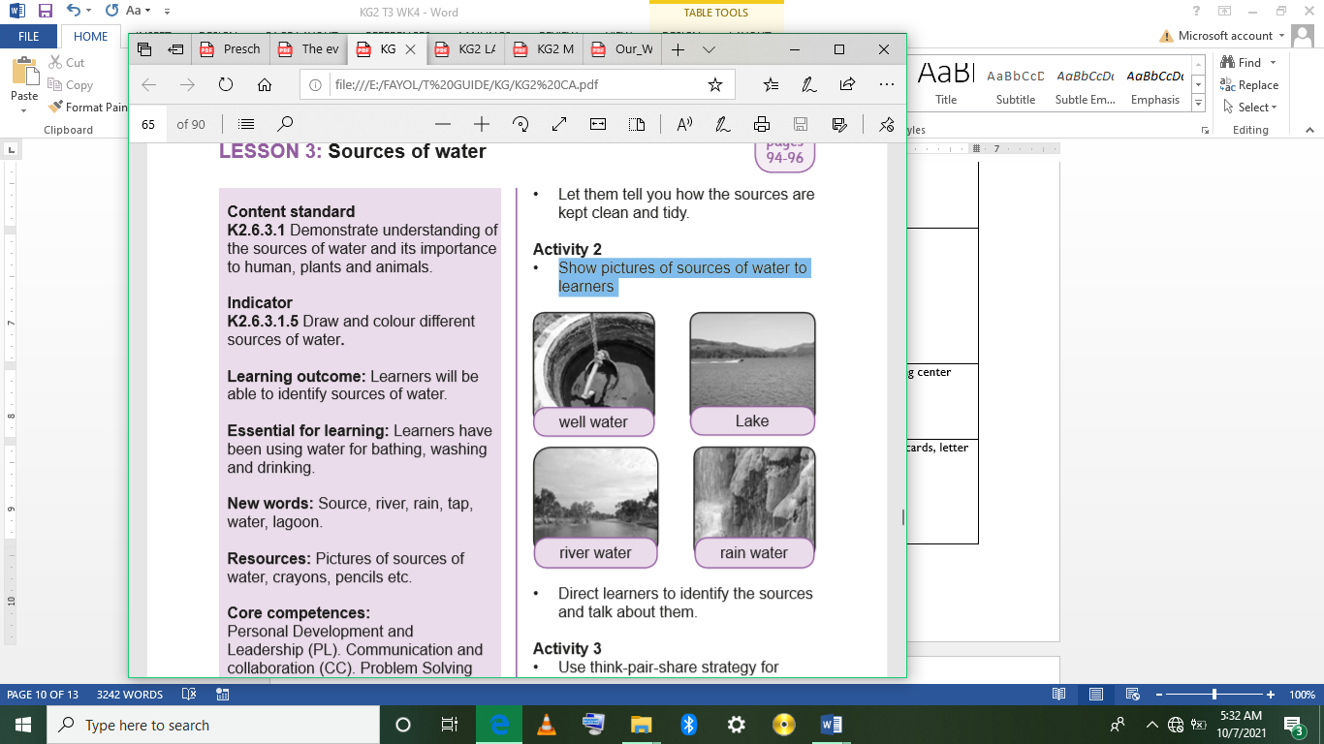  Direct learners to identify the sources and talk about them.  Use think-pair-share strategy for learners to decide which one they like and why.  Give them outline of some sources of water to trace and color. They should work in pairs.  Assessment  Have learners write or copy labels beneath their work and hang them on a big poster labelled “Our Work”.
LEARNING CENTER | Engage learners to play freely at the learning centers.  Observe, join in and ask learners questions frequently to guide their play and to support their understanding in what they are learning. |  |  |  |  | Learning center
STORY SHARING | Tell learners a story.  Pause regularly and ask questions to make sure learners are following.  Engage learners to act parts of the story.  1. Was the story interesting?  2. What part of the story did you like?  3. what have you learnt from the story? |  |  |  |  | Word cards, letter cards.
PHASE 3: REFLECTION | Learners share what they have learnt with their peers and class.  Give learners homework to do at home.

Date: |  | Day: WEDNESDAY |  |  | Strand: All Around Us
 |  |  |  |  | Sub Strand: Water
Class: KG 2 |  |  | Class Size:
Content Standard:  K2.6.3.1 Demonstrate understanding that water is an important natural resource that helps all living things, human, plants and animals |  |  |  | Indicator:  K2.6.3.1.1 Discuss where we get water from, its importance to living things and how to care for water sources
Performance Indicator:  - Learners can discuss where we get water from, its importance to living things and how to care for water sources |  |  |  |  | Core Competencies:  Communication and collaboration, Critical thinking, Personal Development and Leadership
Keywords: sources, river, well, rain, tap, sea, stream, borehole
Reference : KG Curriculum P.g. 166-169
Phase/Duration | Learners’ Activities |  |  |  |  | Resources
PHASE 1: STARTER | Let learners sing a song in relation to the lesson.  1. Did you enjoy the song?  2. What words did you hear in the song?
PHASE 2: NEW LEARNING  CIRCLE TIME | Collect several items and place them in a paper bag.  Reach into the bag with a cloth and remove one item, keeping it covered all the time.  Set the cloth-covered item between you and your learners.  Carefully reveal a small portion of the item.  Have learners try to guess the item. |  |  |  |  | Paper bag
GROUP ACTIVITY 1  (OUTDOOR) | Have learners be in a community circle. Let them play “Pass the ball”. Learners pass the ball to their best friends.  In a semi-circle, ask questions for different learners to answer.  E.g. 1. What kind of water do you have in your home?  2. What kind of water do you have in your community?  3. Who takes care of the water?  Get as many learners to answer and let them also ask you questions.  Show pictures of the various sources of water to learners in their groups.  They look at them and pass them on to the next group. Sea, river, well, rain, etc. Guide learners to look at the pictures and call the name of the particular water.  Field trip: If you have any form of water in the school or in the community, take learners on a field trip to where the water is. They should mention the name of the water. (well, borehole, river, etc.)  Assessment  Have learners work in groups of five. Give them the pictures of the different types of water.  One pick one and the rest mention its name. |  |  |  |  | Pictures of different types of water, crayons, coloured pencils, pencils.
PHONICS | Engage learners to sing songs and recite some familiar rhymes that relates to the target sound.  Guide learners to pronounce and write the target sound in the sand tray or exercise books.  Have learners say three or four words that contain the target sound.  Using flash cards, learners read words that contain the target sound.  1. What sound have we learnt today?  2. Which other letter sound do you know?  3. Mention any object in the classroom or home that begins with the target letter sound. |  |  |  |  | Word cards, letter cards.
GROUP ACTIVITY 2  (INDOOR) | Using the community circle time introduce the theme for the week.  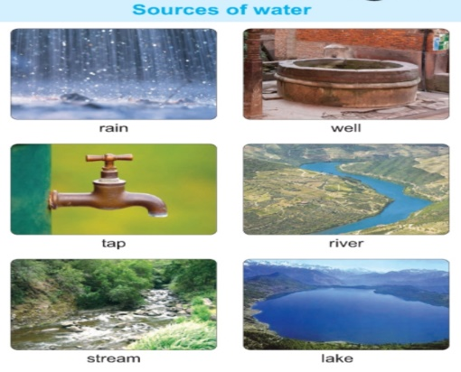  Display a conversational poster (#12) on sources of water and some concrete materials related to the theme and engage learners in active discussion.  Call on learners randomly to answer questions or contribute to the discussion.  Have learners recite a poem/rhyme or sing a song related to them, e.g. “Rain, rain go away.”  Have learners observe the Conversational poster and dictate a story out of the pictures or watch and discuss a video on the sources of water.  Using Language Experience Approach (LEA) have the learners create an informational text on Sources of Water.  Learners dictate the story to you and you write it on a big sheet for them.  Let this become the reading text for the week |  |  |  |  | Pictures of different types of water, crayons, coloured pencils, pencils.
LEARNING CENTER | Engage learners to play freely at the learning centers.  Observe, join in and ask learners questions frequently to guide their play and to support their understanding in what they are learning. |  |  |  |  | Learning center
STORY SHARING | Tell learners a story.  Pause regularly and ask questions to make sure learners are following.  Engage learners to act parts of the story.  1. Was the story interesting?  2. What part of the story did you like?  3. what have you learnt from the story? |  |  |  |  | Word cards, letter cards.
PHASE 3: REFLECTION | Learners share what they have learnt with their peers and class.  Give learners homework to do at home.

Date: |  | Day: THURSDAY |  |  | Strand: All Around Us
 |  |  |  |  | Sub Strand: Water
Class: KG 2 |  |  | Class Size:
Content Standard:  K2.6.3.1 Demonstrate understanding that water is an important natural resource that helps all living things, human, plants and animals |  |  |  | Indicator:  K2.6.3.1. 2 Demonstrate how sentences are written with spaces between the words  K2.6.3.1.3 use a variety of new vocabulary learnt about the sources and importance of water to all living things to create a text for reading using LEA.  K2.6.3.1.4. blend the letter-sounds learn so far into syllables, read and write the syllables boldly and legibly in their books
Performance Indicator:  Learners can  - Demonstrate how sentences are written with spaces between the words the conversational poster on domestic animals.  - Use a variety of new vocabulary learnt about the sources and importance of water to all living things to create a text for reading using LEA.  - blend the letter-sounds learn so far into syllables, read and write the syllables boldly and legibly in their books |  |  |  |  |  | Core Competencies:  Communication and collaboration, Critical thinking, Personal Development and Leadership
Keywords: Dictate, sources, water
Reference : KG Curriculum P.g. 166-169
Phase/Duration | Learners Activities |  |  |  |  |  | Resources
PHASE 1: STARTER | Let learners sing a song in relation to the lesson.  1. Did you enjoy the song?  2. What words did you hear in the song?
PHASE 2: NEW LEARNING  CIRCLE TIME | Guide learners to trace outlines of their hands on several sheets of paper.  Have learners color the hands, turning them into anything she likes such as a turkey, rooster, flower garden, face with big hair, sunrise, funny monster, porcupine, and so on.  See how many different things they can make from thier hand outline!  They can also make foot drawings, too, and see what your learners can make from them.
GROUP ACTIVITY 1  (OUTDOOR) | Use the Big book on the Thirsty Crow. Do a Picture walk through the text and have learners guess what the text will be about.  Read the story aloud with all enthusiasm and pause often for the learners to predict what happens next in the story.  Ask simple Story map questions on the setting, characters, the problem and the resolution of the problem.  Learners think-pair share and then brainstorm as a whole class how water is very important to human beings and plants.  Have learners to draw parts of the story. Create a gallery with the pictures and paste on the classroom walls.  Let learners act or role-play parts of the story. The role-paly should educate on the importance of water.  Assessment  Using think-pair-share, let them brainstorm how water is very important to human beings, plant and animals.  Have learners sing a song on the alphabet. A.B.C.D.E.F.  Revise the letter-sounds learnt so far with learners. Say the sound three times and let learners repeat after you. Write the letter-sound on the board.  /a/, /b/, /c/, /d/, /e/, /u/, /v/, /p/.  Give the letter-sound cards to learners in their groups. Let them pronounce the letter-sounds in turns.  Guide learners to blend individual letter-sound to form one syllabic word.  Let them practice creating many mono syllabic words putting together consonant and vowel sounds e.g (ba).  Use the “Pupils blending process”  Call two learners to the front of the class.  Give them a consonant and a vowel sound. Let them hold individual letter cards separately.  Let them move gradually and slowly towards each other until they stand close to each other and put their letters together to read a syllable.  Let learners practice more of this letter together to read a syllable  e.g. (1) m a  (2) f a  (3) b a  Pupils practice more of this process to help them blend sounds easily.  Learners make their own simple words and copy them into their books  Assessment  Have learners work in pairs. Let them blend these letter-sounds to make syllables.  1. /d/, /a/→da  2. /s/, /o/→so  3. /p/, /o/→po |  |  |  |  |  | Pictures of sources of water
PHONICS | Engage learners to sing songs and recite some familiar rhymes that relates to the target sound.  Guide learners to pronounce and write the target sound in the sand tray or exercise books.  Have learners say three or four words that contain the target sound.  Using flash cards, learners read words that contain the target sound.  1. What sound have we learnt today?  2. Which other letter sound do you know?  3. Mention any object in the classroom or home that begins with the target letter sound. |  |  |  |  |  | Word cards, letter cards.
GROUP ACTIVITY 2  (INDOOR) | Display pictures of sources of water to learners.  Have learners observe the pictures. Write the keywords on the board.  Use illustrations and pictures to explain the meaning to learners. Put learners into groups of five.  Give them the word cards to play; ‘pick and read’. You pick the word and you read the words {(1) well (2) crow (3) river (4) grow (5) well (6) drink (7) crow.}  With leading questions? guide them to form simple sentences orally and write a simple story for them.  Let learners dictate their sentences and write them on the board E.g.  1. I drink water everyday.  2. Animals also drink water.  3. It is raining heavily.  4. There is a well in our school.  5. The bore-hole in the community is too deep.  Encourage learners to give a title to the text. E.g (different kinds of water).  Assessment  Have learners work in pairs. Give them three word cards with which they can form sentences
LEARNING CENTER | Engage learners to play freely at the learning centers.  Observe, join in and ask learners questions frequently to guide their play and to support their understanding in what they are learning. |  |  |  |  |  | Learning center
STORY SHARING | Tell learners a story.  Pause regularly and ask questions to make sure learners are following.  Engage learners to act parts of the story.  1. Was the story interesting?  2. What part of the story did you like?  3. what have you learnt from the story? |  |  |  |  |  | Word cards, letter cards.
PHASE 3: REFLECTION | Learners share what they have learnt with their peers and class.  Give learners homework to do at home.

